**PART A**

(Part A: TO BE REFERRED BY STUDENTS)

**Experiment No. 01**

**A.1 AIM:**

Observing a Website. Study about its content, structure.

**A.2 Pre requisite:**

Basic Knowledge of Internet, Web Browsers, Web Servers.

**A.3 Outcome:**

After successful completion of this experiment students will be able to:

1. Understand structure of web pages.
2. Understand content of web pages.
3. Features & shortcomings of the website.
4. Working of Web Browsers, Web Servers, Protocols & Client Server Architecture.

**A.4 Theory:**

Website or simply site, is a collection of related web pages, including multimedia content, typically identified with a common domain name, and published on at least one web server. A website may be accessible via a public Internet Protocol (IP) network, such as the Internet, or a private local area network (LAN), by referencing a uniform resource locator (URL) that identifies the site.

Websites have many functions and can be used in various fashions; a website can be a personal website, a commercial website for a company, a government website or a non-profit organization website. Websites are typically dedicated to a particular topic or purpose, ranging from entertainment and social networking to providing news and education. All publicly accessible websites collectively constitute the World Wide Web, while private websites, such as a company's website for its employees, are typically a part of an intranet.

**PART B**

(PART B: TO BE COMPLETED BY STUDENTS)

(Students must submit the soft copy as per following segments within two hours of the practical. The soft copy must be uploaded on the Blackboard or emailed to the concerned lab in charge faculties at the end of the practical in case the there is no Black board access available)

|  |  |
| --- | --- |
| Roll No. : N049 | Name: Tarun Tanmay |
| Class : MbaTech CS | Batch : B3 |
| Date of Experiment : | Date/Time of Submission : |
| Grade : |  |

**B.1 Code:**

*(Paste your learnings here)*

**B.2 Output:**

**Screenshot 1:**

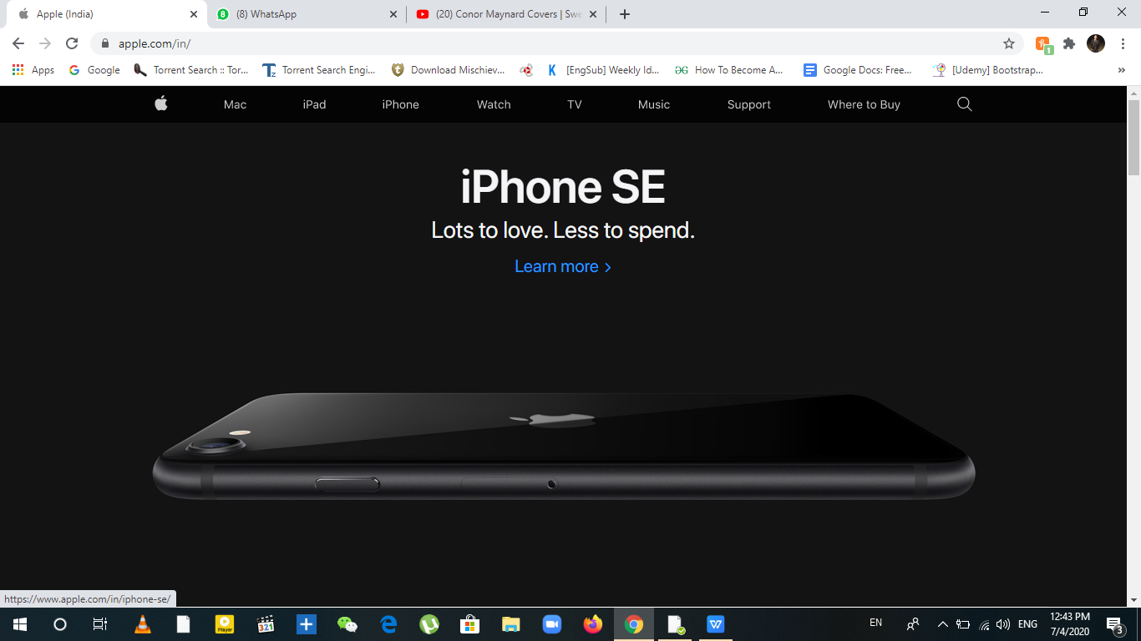

**Screenshot 2:**

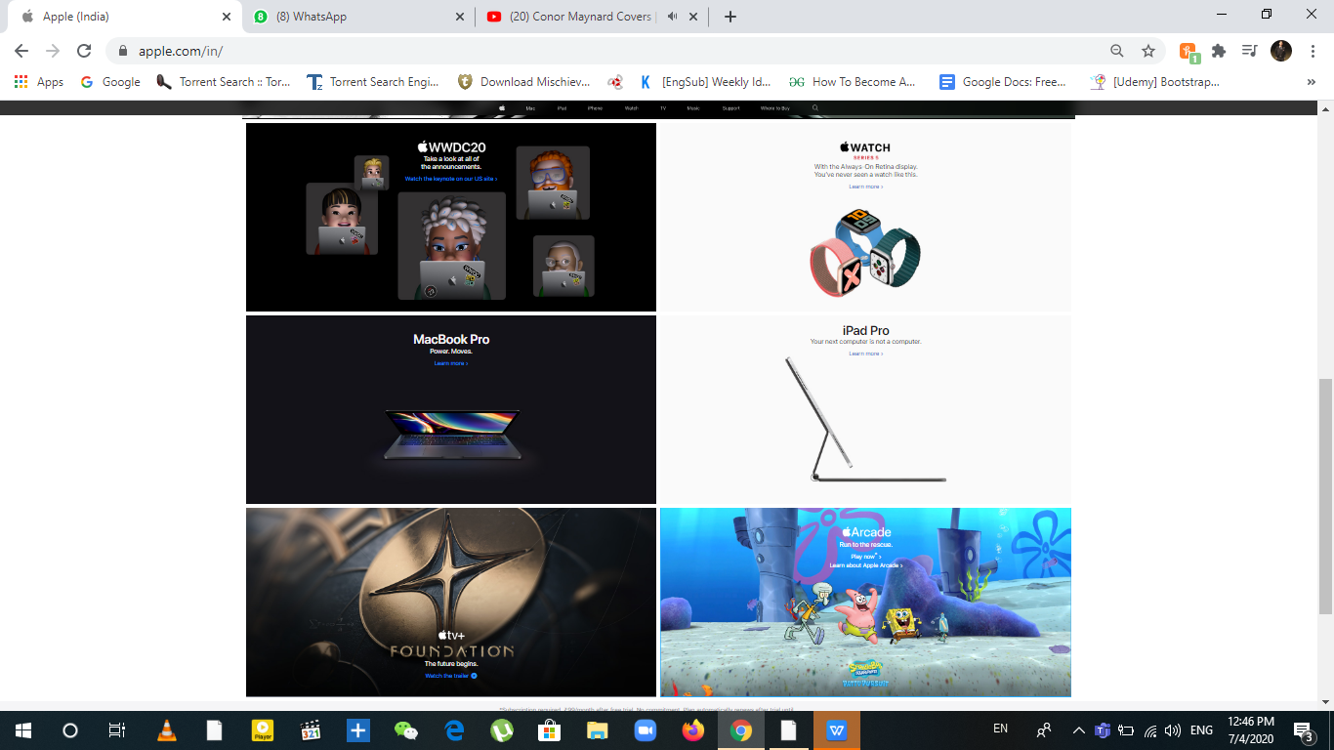

**Screenshot 3 & 4**:

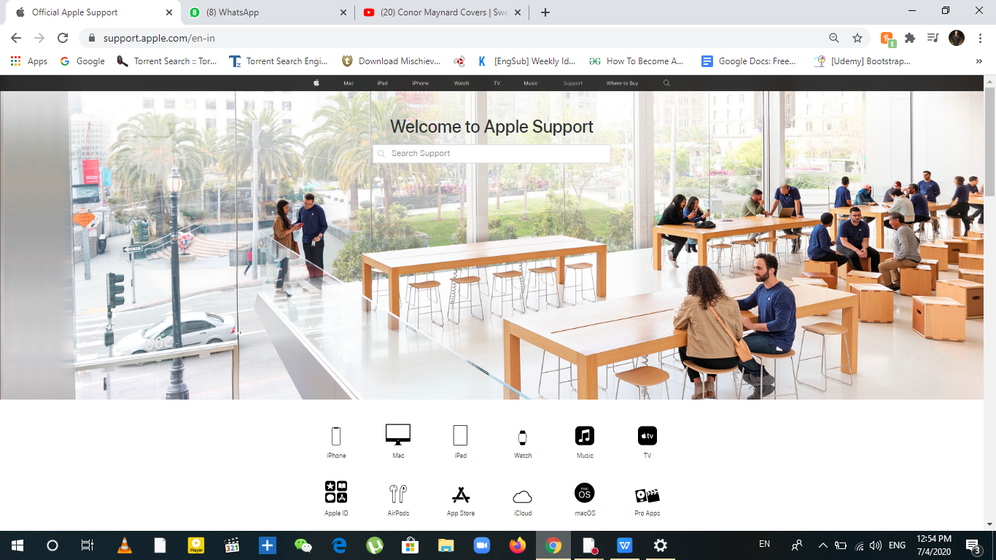

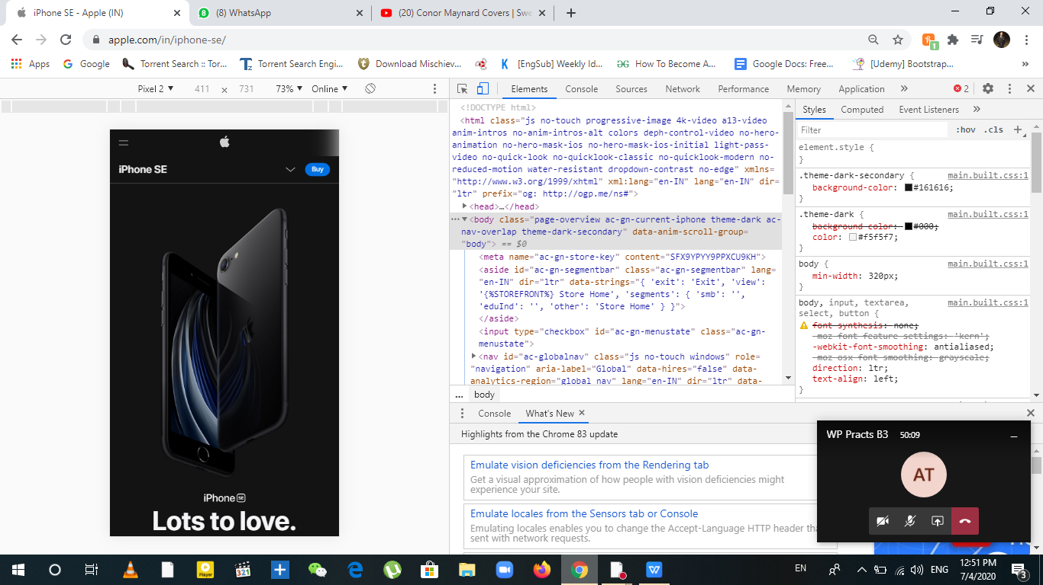

**Screenshot 5 & 6:**

Several Broken Links on Mumbai University Website, when clicking on the Knimbus link there’s a 404 not found error.

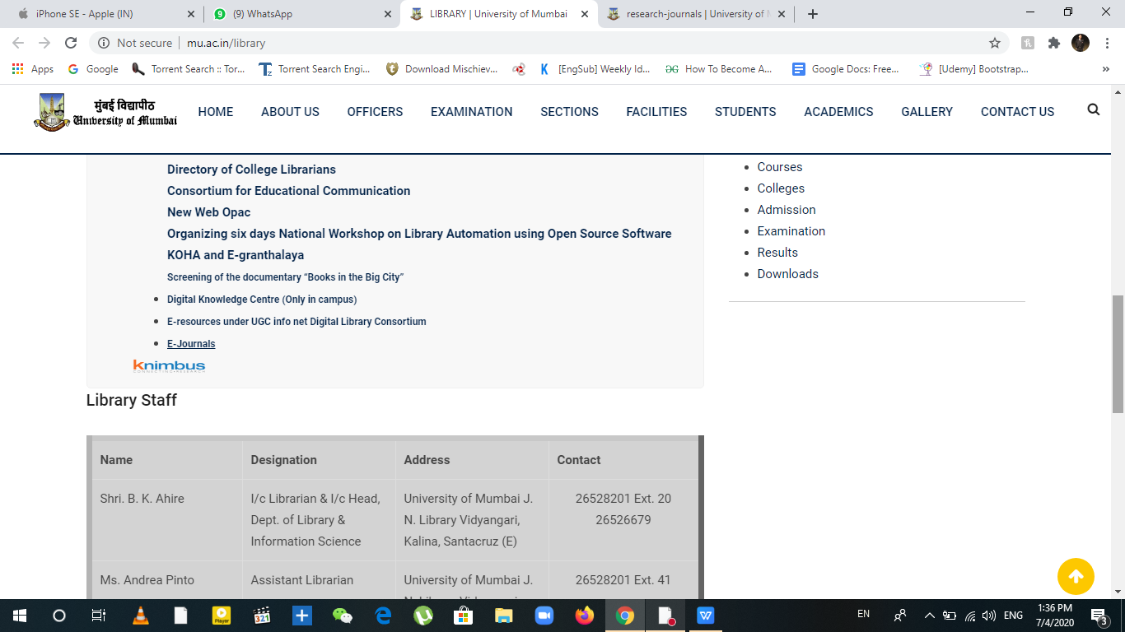

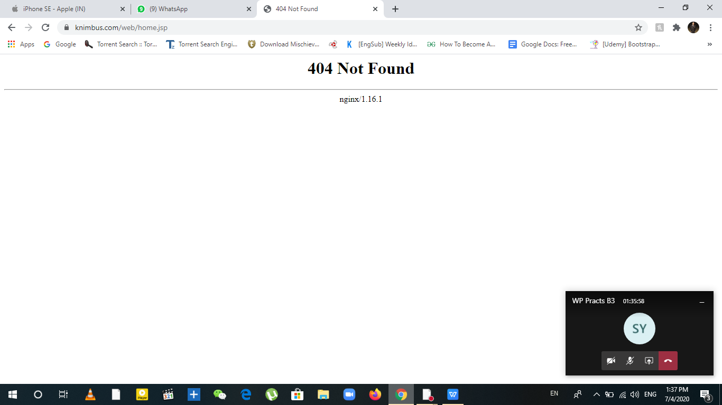

**B.3 Conclusion:**

Under this experiment, I have learned about the basics of web designing. The kind of color coding used which makes the website look nice, using CSS grid or flexbox to organise the content on the website, using navigation bar and jquery for easy access, and the necessity of removing all the broken links to make it error free.

**B.3 Observations and Learning:**

**Advantages of Website:**

1. **Screenshot 1**: In the header, Apple logo is used as “favicon” which can be seen in the web bar, also the same icon is used in the navigation bar as “navicon” which is used as home button . The color coding in black, gray and white of the website seems appealing. The Navigation bar stays at top above all the content even after scrolling because of good jquery programming for smooth scrolling.
2. **Screenshot 2**: The website uses CSS Grid template, we can see columns as 3fr - 2fr. The links get underlined when we hover over them.
3. **Screenshot 3**: The website has a support page linked in the navigation bar, which uses a background image with 100vh viewport height. So when the website is zoomed in or out, the image still covers the whole screen. Also, some specific icons are used which actually contain the link tags.
4. **Screenshot 4**: The Website is fully optimized i.e. responsive , so it can be viewed in any device and according to max-width the content on the website automatically adjusts for the viewer. The navigation bar changes to one single cross drop down menu button for small width devices.

**Limitations of the Website:**

1. On clicking the links in those sections, a new web page opens in the same tab because there is no “_blank” attribute attached in redirect target part of the tag.
2. The “learn more” link has a side arrow key (>) next to it, which is actually a dot at first but it is using transition and animation property in CSS. So when site loads on slow networks, it appears as a dot rather than an arrow. Hence, no point of using this animation.
3. On Widescreen view mode, though the scaling is apt so the background is always at 100vh height but the images in those sections get cropped from sides when viewing at 100 % zoom. We need to zoom out around 80% to view the complete image.

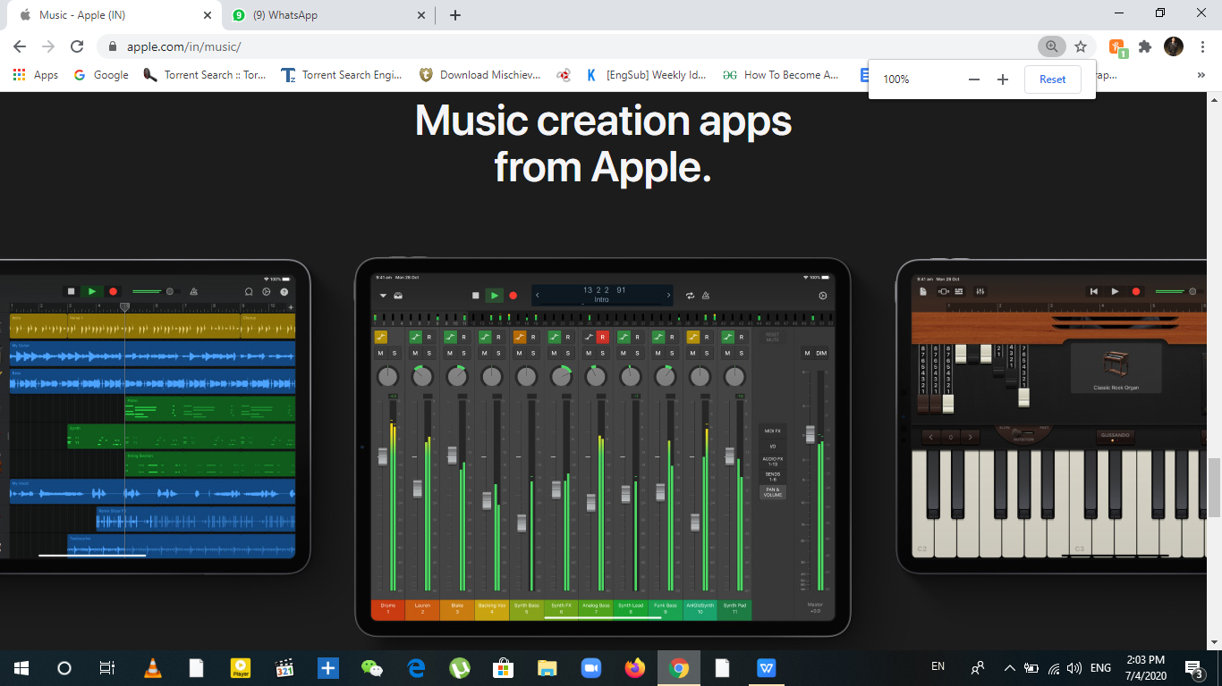

**100% VS 80%**

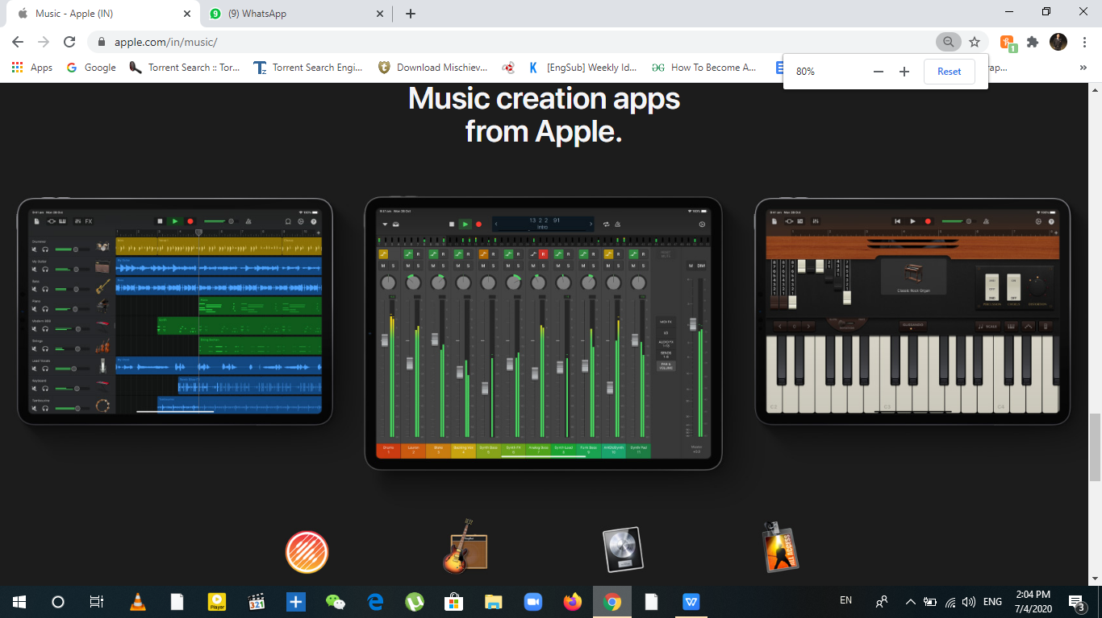

**B.4 Question of Curiosity**

*(To be answered by student based on the practical performed and learning/observations)*

Q.1. What were the shortcomings in the websites visited?

1. On clicking the links in those sections, a new web page opens in the same tab because there is no “_blank” attribute attached in redirect target part of the tag.
2. 2.The “learn more” link has a side arrow key (>) next to it, which is actually a dot at first but it is using transition and animation property in CSS. So when site loads on slow networks, it appears as a dot rather than an arrow. Hence, no point of using this animation.
3. On Widescreen view mode, though the scaling is apt so the background is always at 100vh height but the images in those sections get cropped from sides when viewing at 100 % zoom. We need to zoom out around 80% to view the complete image.